THE INSILICO LAB
3-Week Virtual Training in CADD
Week 1

Protein Target Selection, Binding Site Analysis & Protein Preparation

Participant Name  Amarachi Eze_____________ | Date Submitted  26th May 2026_________________
Cohort / Batch  4___________________ | Email Address  hadassaze@gmail.com________

📋 Instructions
Read all instructions carefully before starting. Each task builds on the previous one. Submit all deliverables to the spaces provided in this template.

TASK 1 | Protein Target Selection and Structure Evaluation

Objective: To demonstrate the ability to select and justify a high-quality protein structure suitable for structure-based drug design.
▸ Task Description
1 | Select the Crystal structure of the Epidermal Growth Factor Receptor tyrosine kinase domain with 4-anilinoquinazoline inhibitor erlotinib (PDB ID: 1M17).
2 | Go to the Protein Data Bank website: https://www.rcsb.org and search for 1M17.
3 | Download the structure file (.pdb) for visualization.
4 | Open and visualize the structure in PyMOL.
5 | Take screenshots showing the full protein and the co-crystallized ligand.

▸ Deliverables — Complete the Table Below

# | Deliverable | Your Response / Submission
1 | Protein name | Epidermal Growth Factor Receptor
2 | Biological relevance of the protein | EGFR is involved in maintaining epithelial integrity across organs, necessary in homeostasis and repair from injury. It is very critical in embryonic development and neurological function.
3 | Selected PDB ID | 1M17
4 | Experimental method used | X-ray Diffraction
5 | Resolution value (Å) | 2.60 Å
6 | Co-crystallized ligand present? | Yes, 4-anilinoquinazoline

▸ PyMOL Screenshots
Note
Insert at least two screenshots below: (1) full protein view, (2) close-up showing ligand in binding pocket. Label each image clearly.

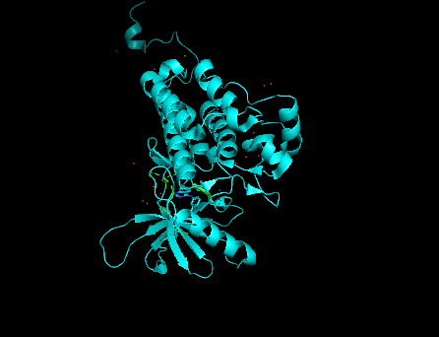[ Insert Screenshot Here ]
Screenshot 1 — Full Protein View (PyMOL)

[ Insert Screenshot Here ]
Scree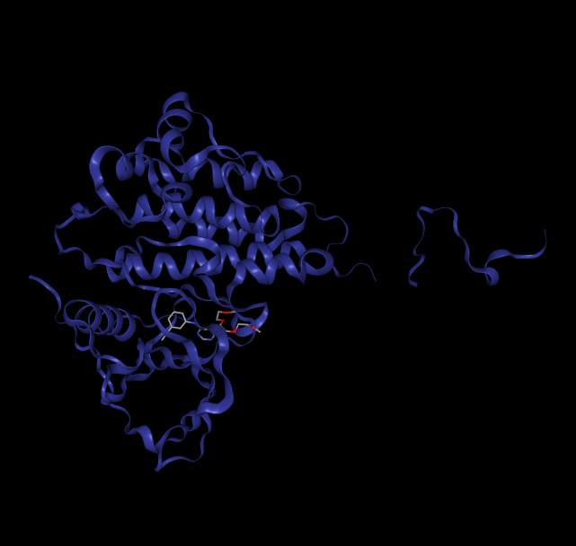nshot 2 — Ligand in Binding Pocket (PyMOL)

▸ Written Justification
Why did you select this structure? Consider resolution, experimental method, ligand presence, and biological relevance. (Write 3–5 sentences below)

This structure was selected because the resolution was fair and within the acceptable range. The experimental method used was x-ray diffraction, and this is preferably for beginners. There is a presence of a ligand, 4 - anilinoquinazoline and this shows that this protein has been worked on, and it gives an idea of the binding site area in the complex protein. This protein has vital biological relevance as it is important in the normal physiological wound healing, and also the growth of cancerous cells.

TASK 2 | Binding Site Identification and Analysis

Objective: To demonstrate the ability to identify, analyze, and justify a biologically relevant binding site using the DoGSiteScorer Binding Site Detection website.

▸ Task Description
1 | Go to the DoGSiteScorer website: https://proteins.plus/ and upload your PDB file (1M17).
2 | Run the binding site prediction.
3 | Identify the top-ranked binding pocket and note its key residues.
4 | Open PyMOL and highlight the residues identified by DoGSiteScorer.
5 | Take screenshots showing the binding pocket clearly labelled.

▸ Deliverables — Complete the Table Below

S/N | Deliverable | Your Response / Submission
1 | Tool used for binding site prediction | DoGSiteScorer
2 | Chain used for analysis | Chain A
3 | Name / rank of top binding pocket | Pocket P_0
4 | Key residues in the binding site (list at least 5) | LEU694, VAL702, ALA719, ILE720, LYS 721, GLU738
5 | Brief explanation of how the tool works | Dogsite scorer helps to detect binding site in a protein. It also provides the residues that are loaded in the proteins. It also shows clearly the binding pocket and area.

▸ PyMOL Screenshots — Binding Pocket
Note
Insert at least two screenshots: (1) binding pocket surface view, (2) residues labelled/highlighted. Annotate residue names where possible.

[ Insert Screenshot Here ]
Screenshot 3 — Binding Pocket Surface (P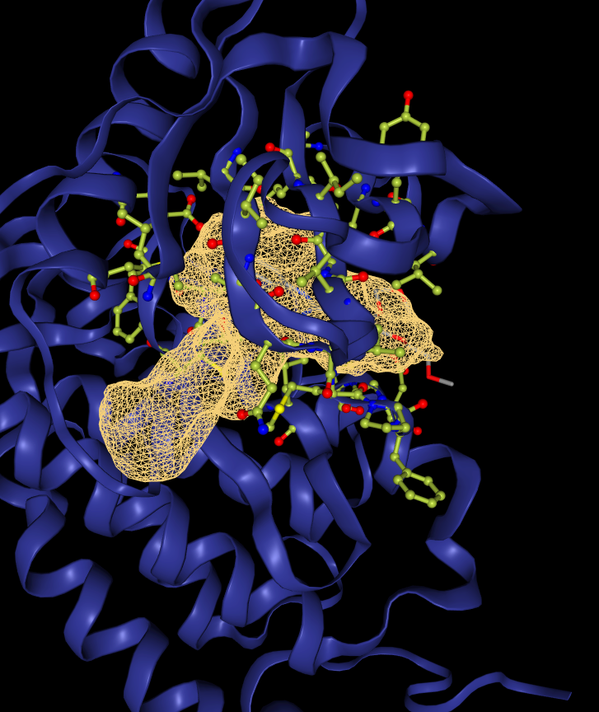yMOL)

[ Insert Screenshot Here ]
Screenshot 4 — Labelled Binding Site Residu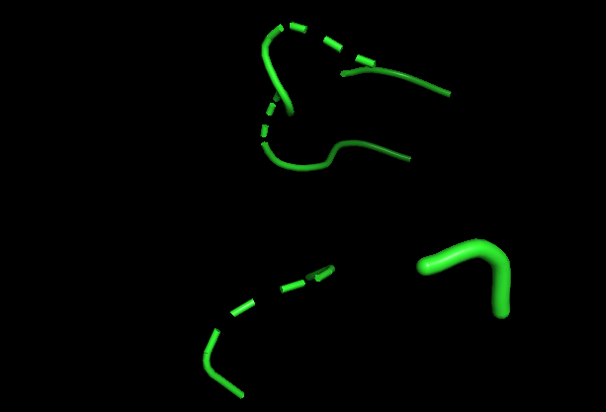

▸ Brief Validation Notes
Explain how you confirmed this is the correct binding site. (Write 2–4 sentences below)

I confirmed that this is the correct binding site first from the dogsite score, it showed us where the ligand was most likely bound to. The on with the highest bind value was deduced from dogsite scorer as the correct binding site.

TASK 3 | Protein Preparation and Cleaning

Objective: To demonstrate the ability to prepare a protein structure for molecular docking following best practices.

▸ Task Description
1 | Open 1M17 in UCSF Chimera (File → Open → select your PDB file).
2 | Inspect the structure: identify water molecules, co-factors, and alternative chains.
3 | Select Chain A only and delete all other chains if present
4 | Remove irrelevant water molecules and any unwanted cofactors/ligands.
5 | Use Dockprep (Tools → Structure Editing → Dock Prep) to add hydrogens and charges.
6 | Save the prepared structure as a new PDB file (e.g., 1M17_prepared.pdb).
7 | Open both the original and prepared files in PyMOL for before-and-after comparison.

▸ Step-by-Step Preparation Summary
Fill in each step you complete. Be concise and specific.

Step | Action Performed | Observation / Result
1 | I opened the legacy protein pdb in Chimera | It loaded with the ligand by the side in a big view/layout.
2 | I inspected the structure, to identify water molecules, no. of protein chains, and any other bound co-factors or solvents | Single chain A with water molecules and amino acid residue was observed.
3 | I used the Dockprep tool to prepare the protein to optimize the hydrogen atoms needed | The job was done.
4 | I saved the pdb as a fresh file | Saved as 1M17-prepared
5 | It was opened in Pymol | Used for comparison.
6
7

▸ Before-and-After PyMOL Screenshots
Note
Show the protein BEFORE preparation (raw PDB) and AFTER preparation (cleaned, one chain, hydrogens added). Both images should be at the same zoom level for easy comparison.

[ Insert Screenshot Here ]
Screenshot 5 — BEFORE Preparation (raw 1M17 in PyMOL)

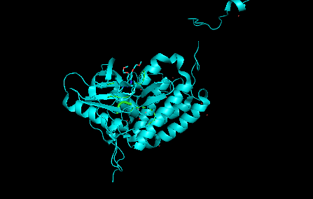[ Insert Screenshot Here ]
Screenshot 6 — AFTER Preparation (1M17_prepared.pdb in PyMOL)

▸ Prepared Structure File
S/N | Deliverable | Your Response / Submission
1 | Prepared PDB file name | 1M17_prepared.pdb
2 | Number of chains remaining | Chain A
3 | Water molecules removed? | Yes
4 | Hydrogens added via Dockprep? | Yes
5 | Any issues encountered? | None

📣 LINKEDIN PORTFOLIO POST
Week 1 — Required Submission

Important
This is ONE single post combining all three tasks. Do NOT create three separate posts.

▸ What to Include in Your Post

# | Deliverable | Your Response / Submission
1 | Annotated PyMOL image of selected protein (Task 1) | Insert your screenshot
2 | Caption: why this structure was chosen (Task 1) | Write 2–3 sentences
3 | PyMOL image highlighting the binding pocket (Task 2) | Insert your screenshot
4 | Caption: how the binding site was identified (Task 2) | Write 2–3 sentences
5 | Before-and-after protein preparation images (Task 3) | Insert both screenshots
6 | Caption: why protein preparation matters (Task 3) | Write 2–3 sentences

▸ Tagging & Hashtags
Tag: @The Insilico Lab

#CADD | #DrugDiscovery | #ComputationalBiology | #VirtualResearch | #TTheInsilicoLab | #Chemoinformatics

End of Week 1 Assignment
Good luck! The Insilico Lab Team

